

Maxx Lacie

Maxx and Lacie are Shepard mixes who are seven months old. They were born in June of 2006 and are between 30-40 pounds each. The puppies have not been separated since birth and are very close to each other. They are very well behaved and a great aspect they have is that they do not bark very much at all.

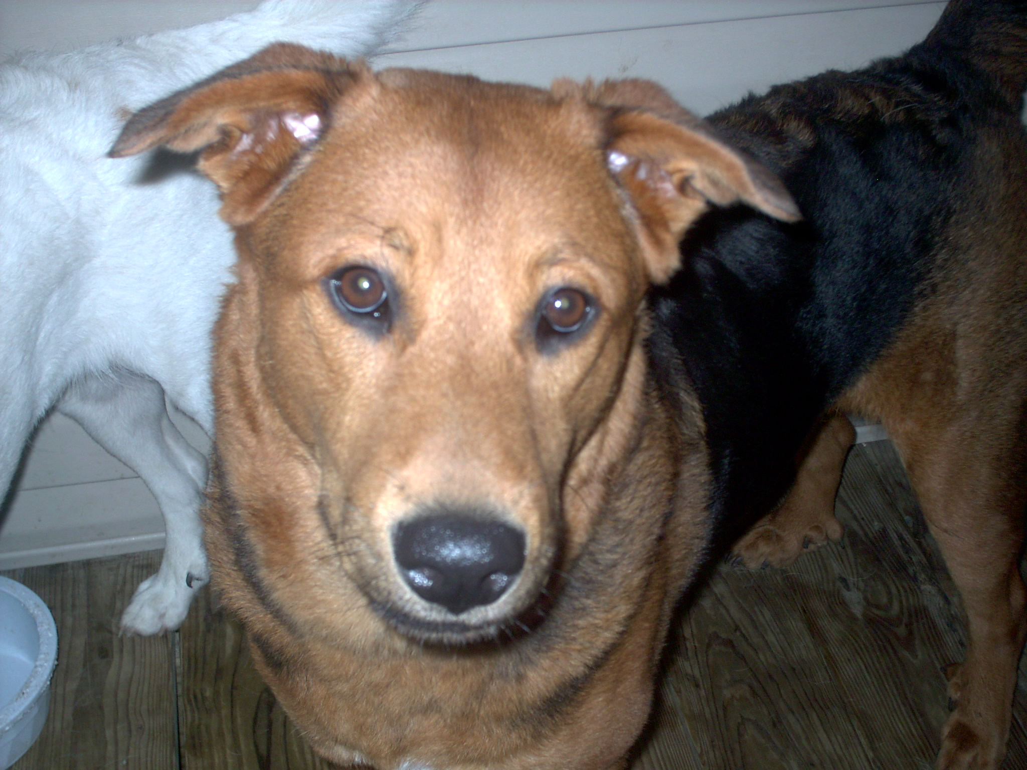
Maxx is very loving and affectionate dog. If it was not for his size he would be a lap dog. Maxx is not that active, he plays but he is more content giving hugs and kisses and laying on the couch. He loves to cuddle, he will put his arms on your shoulder and put his four head to yours. His nick name is “ the investigator” because he sniffs everything. Nothing gets past Maxx.

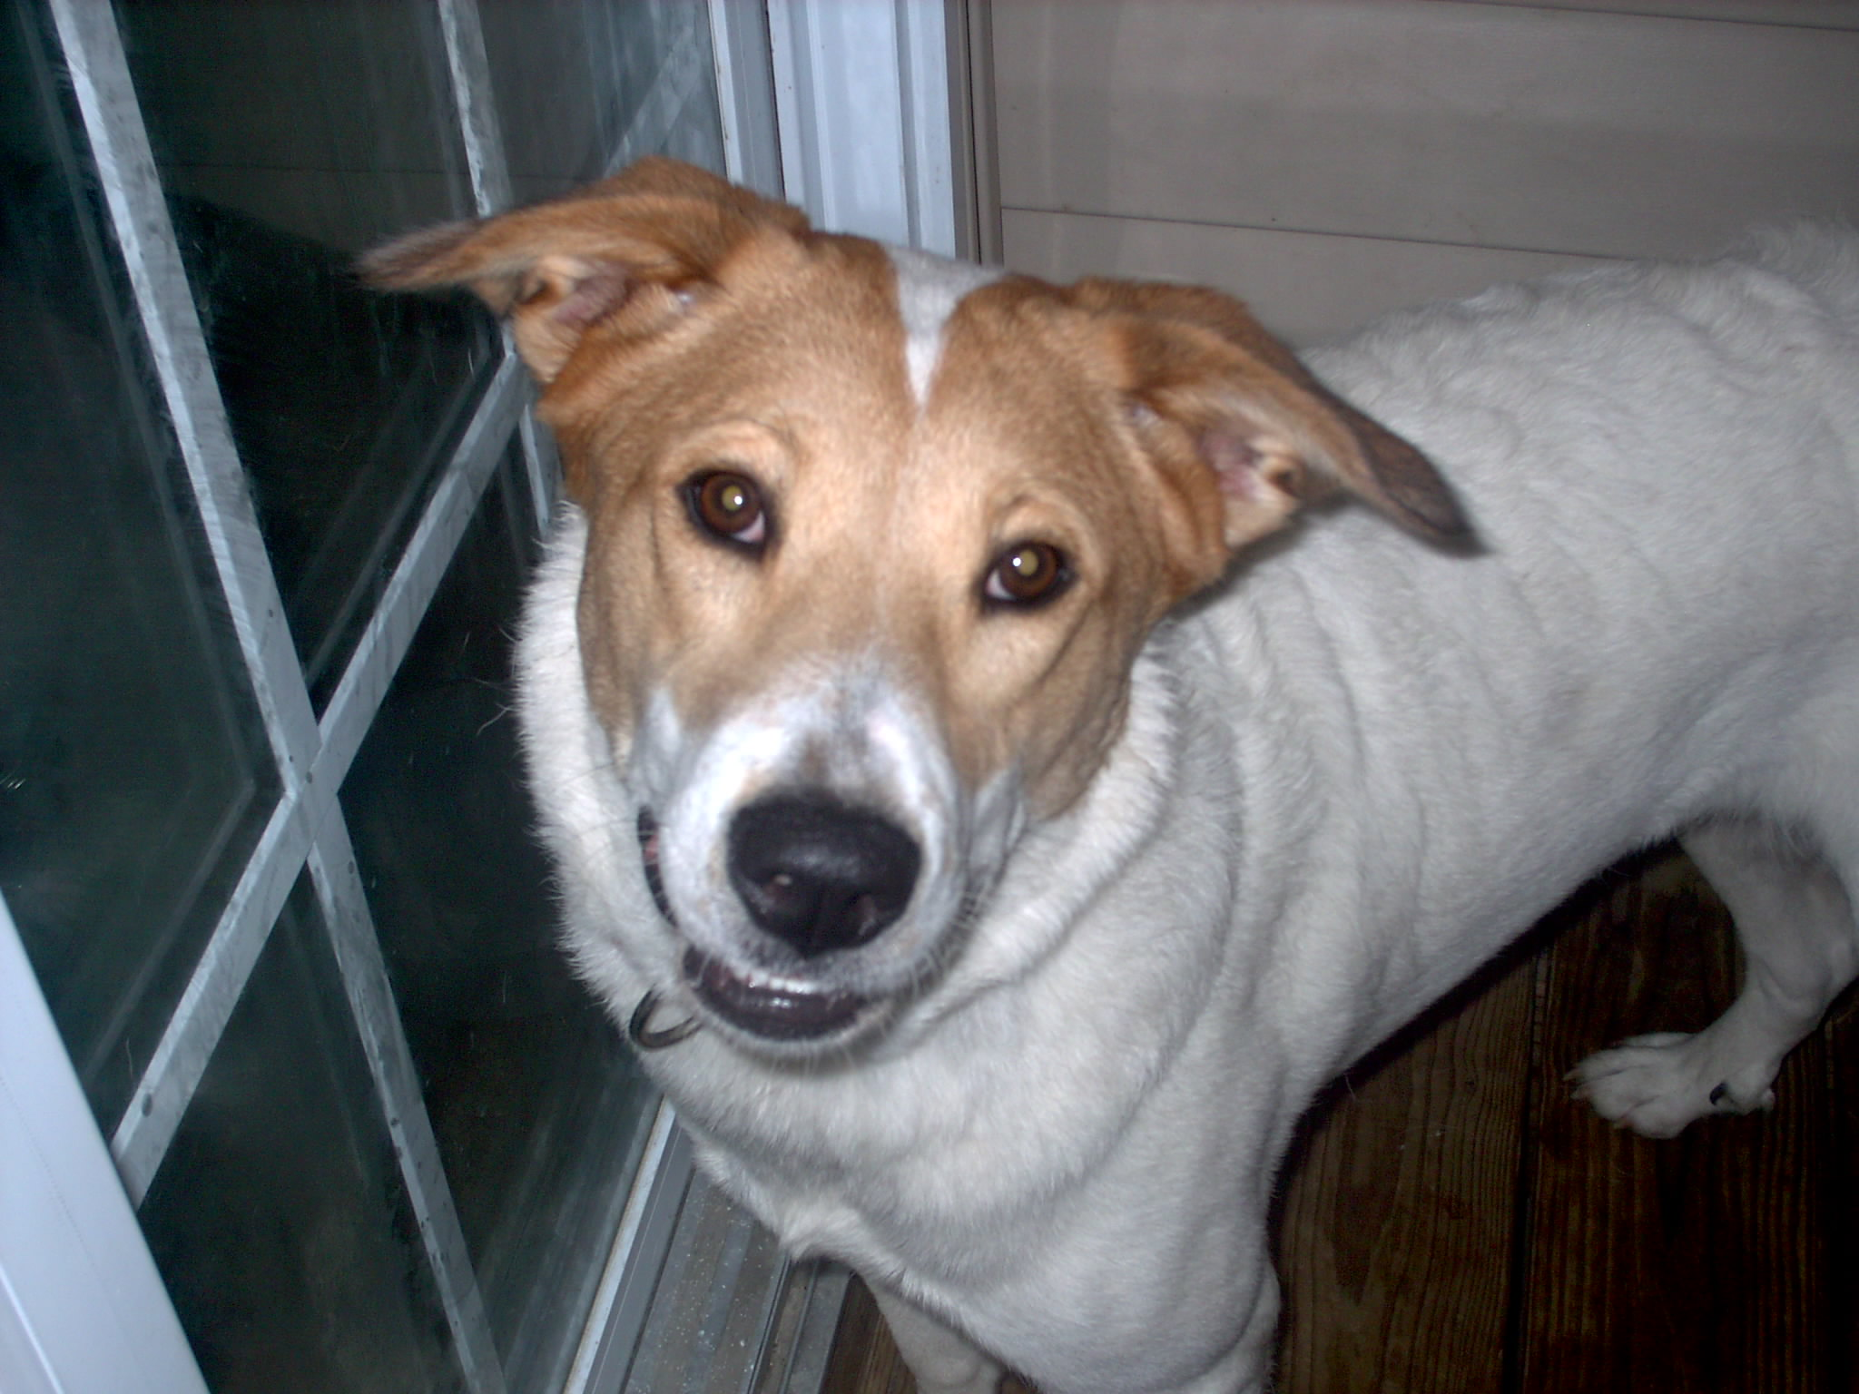

Lacie is a fun and loving dog. Lacie is the active of
The two. She loves to give kisses but she loves to
play. He loves to play fetch with tennis balls and to
chew on bones. She loves to be outside and to take
walks. Lacie has been nicked name our “protector”
because if anything spooks them she is the one to
stand up.

